|  |
| --- |
| **Saxion University of Applied Sciences** |
| WEEK 1 VHDL |
| VHDL 2018-2019 |
| **System Requirements**  **Project Integration 2019-2020**  *Author: D. Rangelov, A. Belyakov,* *Y. Chen,* *T. Cao, J. Qazi*  *Tutor: R. Kirmali, J.S.D Stokkink, U. Guler*  *Version: 0.0.1* |
| **Author : Dimitar Rangelov Student number 445392** |
| Tutor: J.S.D. Stokkink |

Version 0.0.1



**Names & Addresses**

|  |  |  |  |
| --- | --- | --- | --- |
|  | **Arsenii Belyakov** | 450835 | 450835@saxion.nl |
|  | **Dimitar Rangelov** | 445392 | 445392@saxion.nl |
|  | **Yiming Chen** | 423960 | 423960@saxion.nl |
|  | **Tianru Cao** | 454286 | 454286@saxion.nl |
|  | **Junaid Qazi** | 443406 | 443406@saxion.nl |



**Contents**

1. Introduction 4

1.1 Introduction to project 4

1.2 Overview of document 4

2. Functional description and requirements 5

2.1 Functional description 5

2.1.1 Use scenarios 5

2.1.2 User requirements 6

2.1.3 Functions 7

2.1.3.1 Smartwatch 7

2.1.3.2 Mother Device 7

2.2 Functional Requirements 8

2.2.1 User Interface Requirements 8

2.2.2 Motion Control Requirements 8

2.2.2.1 Motion Control Table 9

2.2.3 Heart Rate Detection Requirements 9

2.2.3.1 Heart Rate Detection Table 9

2.3 External Interfaces 10

2.3.1 Software Interfaces 10

2.3.1.1 User Interface 10

2.3.1.2 Standard Software Interface 10

2.3.2 Electrical Interfaces 10

2.3.3 Mechanical Interfaces 10

2.4 Requirements on External Interfaces 11

2.4.1. External Interface 1: User 11

. 3. Design architecture and requirements 12

3.1. Design Architecture 12

3.2 Technical requirements 12

3.2.1 Safety Requirements 12

3.2.2 Cost 13

3.3.3 Physical properties 13

3.2.4 Environmental Design Requirements 13

3.2.4.1 14

3.2.5 General Design Requirements 14

3.2.5.1 15

3.2.6 Mechanical Design Requirements 15

3.2.7 Electrical and Electronic Design Requirements 15

3.2.8 Software Design Requirements 16

3.2.9 Production and assembly 16

3.2.10 Reliability 16

3.2.11 Maintainability 17

4. Quality Assurance Provisions 18

4.1 Verification setup 1: control 18

4.1.1Purpose of test/analysis 18

4.1.2 Test setup/Analysis method 18

4.1.3 Test procedure/Analysis process 18

4.1.4 Test/Analysis data recording 18

4.1.5 Processing and evaluation of results 18

4.2 Verification setup 2: dynamics 18

4.2.1 Purpose of test/analysis 18

4.2.2 Test setup/Analysis method 19

4.2.3 Test procedure/Analysis process 19

4.2.4 Test/Analysis data recording 19

4.2.5 Processing and evaluation of results 19

5. Appendix 20



# 1. Introduction

## 1.1 Introduction to project

The purpose of this document is to give a detailed description of the requirements for the smartwatch and healthcare robot for the Project Integration. It will illustrate the purpose and complete declaration for the development of system. It will also explain system constraints, interface and interactions with other external applications. This document is primarily intended to be proposed to a customer for its approval and a reference for developing the first version of the system for the development team

**Scope**

The assignment for ‘Project Integration’ is to create a ‘healthcare robot’ which can assist in certain tasks for a target group that will be chosen by the project members themself.  
Project integration is a project that lasts two modules, or one semester, and will start at the beginning of quarter 3 and will last till the end of quarter 4.

The “Healthcare system“ for Project integration is consisting of two main devices – smart watch and mother device (healthcare robot). The smart watch will have several sensors that will measure the heart beat and temperature eventually. Also will have gyroscope to follow if the elder people did not drop on the floor. There is a button for SOS and if there is an emergency situation can be pressed and there will be signal. At the same time the healthcare robot will follow the schedule of the client for his/her pills. And will make notification of her/his watch if the time for their pills is. Everything will be user-friendly and easy going adapter to the target group.

## 1.2 Overview of document

This document defines the system that is to be developed both functionally and technically and is going in depth in functional and technical requirements that the systems should fit.

The remainder of this document includes four chapters and appendixes. The second one covers the functional aspects as functions of the systems, functional requirements, external interface and etc. . Further, the chapter also mentions requirements imposed on its external interfaces and assumptions about the product.

The third chapter provides the technical requirements specification in detailed terms and a description of the different system internal interfaces. Different specification techniques are used in order to specify the requirements more precisely for different audiences. Further, the chapter also mentions the maintenance, reliability and safety requirements.

The fourth chapter deals the quality assurance provisions and the end of the design and realization process of the system.

The Appendixes in the end of the document include all of the concept drawings that were discussed with the client and also all of the ideas and visualizations of the development team.



# 2. Functional description and requirements

This part of the system requirements is defining the functional way how the system will do the functions. Or in other word what kind of functions the system will have.

# 2.1 Functional description

## 2.1.1 Use scenarios

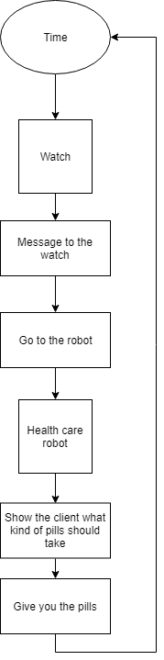

The first scenarios that is present in the picture above is the methodology how the clients will their pills. When time for their pills is will be send a message to the watch and that will trigger an alarm or reminder. The client will go to the health care robot (the main device) and the robot will show him/her what kind of pills should take and probably will be option to show what pills will be for what. After that will give to the client the pills. In that case the clients won’t forget for their pills.

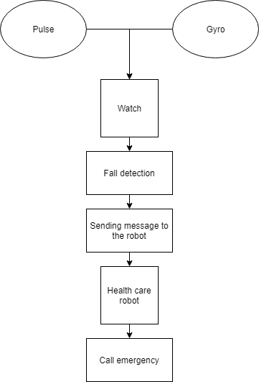

The second scenario in the picture above is the emergency case scenario. In the situation the smart watch is following your pulse and the position of your body. And is collecting this information and when the client fall the fall detection will be activated. In case that the client fall on the floor the smart watch will send a message to the health care robot and after that the robot will call the emergency number. Meanwhile will still follow the data of the client via the smart watch.

These two pictures and descriptions are representing the two main scenarios that the development team will focus on in this project.

## 2.1.2 User requirements

The two scenarios consist specific user requirements that are really important to the realization of the products.

The first scenario with the taking the pills the user requirements is to have a message that remind them to take the pills. The second user requirement is to have device to give and store the client’s pills. And another user requirement is the pills to be give with specifying schedule.

The second scenario “Emergency situation” consists of 3 user requirements. The first requirements are to have device that will measure the pulse and the position of the body of the client. The second it to have fall detection and the last user requirement is to have device that is calling the emergency phone when the client is fall on the floor.

## 2.1.3 Functions

The end product is considered to be a ‘health robot’ which should assist the user in his or her daily life.  
The end product is divided into two parts:

* Smartwatch
* Mother Device

Each device will have its own function and will contribute to the daily life of the user in its own way.

### 2.1.3.1 Smartwatch

In the next section the main functions of the smartwatch will be defined.

|  |  |  |
| --- | --- | --- |
| Scenario | Function | Description |
| Abnormal Heartbeat | Abnormal Heartbeat Detection | Whenever the heartbeat of the user is abnormal, an emergency message needs to be broadcasted, |
| User has fallen | Fall detection | Whenever the user has fallen, an emergency message needs to be broadcasted |
| User needs to take their medicine | Reminder | Remind the user whenever it’s time to take their medicine. |

### 2.1.3.2 Mother Device

In the next section the main functions functions of the mother device will be defined.

|  |  |  |
| --- | --- | --- |
| Scenario | Function | Description |
| User needs to take their medicine | Reminder | The mother device reminds the user to take their medicine |
| User wants to receive the right medicine | Medicine distribution | The mother device gives the user the right medicine whenever it is time to take their medicine. |

# 2.2 Functional Requirements

The functional requirements are defined as the requirements that explain what all the functions of the end product will be.

It is less technical and more about the general requirements such as functionality, speed and accuracy.

## 2.2.1 User Interface Requirements

One of the most important parts of the end product is to have a user interface that is

easy to understand and gives a smooth experience to the previously chosen target group.  
In the next section the specific requirements for the user interface will be defined.

|  |  |  |  |  |
| --- | --- | --- | --- | --- |
| **Number** | **Requirement** | **Relation** | **Value** | **Unit** |
| FR01 | The user interface of the smartwatch should be easy to navigate | n/a | n/a | n/a |
| FR02 | The user interface of the smartwatch should keep the screen size in mind. All functions of the smartwatch should be accessible even if the screen is on the smaller side. | n/a | n/a | n/a |
| FR03 | The user interface of the mother station should be easy enough to understand while at the same time giving the user all the options to control the system as a whole | n/a | n/a | n/a |
| FR04 | Low learning curve: the user interface as a whole should be easy to learn for a new user | n/a | n/a | n/a |

## 2.2.2 Motion Control Requirements

The health and safety of the user is the main focus of the end product, it is called a ‘health robot’ after all.

One of the main functions of the motion control part is fall detection, where if the user falls and gets hurt, an emergency number is called.  
This function and other motion control functions will be defined in the next section.

### 2.2.2.1 Motion Control Table

|  |  |  |  |  |
| --- | --- | --- | --- | --- |
| **Number** | **Requirement** | **Relation** | **Value** | **Unit** |
| MC01 | Fall detection:  Whenever the smartwatch drops to the floor, which in turn means that the user has fallen, the smartwatch sends a emergency response message to the mother device. | n/a | n/a | n/a |
| MC02 | Tilt detection: Whenever the user tilts the smartwatch in such a way that the screen is in parallel with the users face, the screen turns on | n/a | n/a | n/a |

## 2.2.3 Heart Rate Detection Requirements

One of the main functions of the end product is to be able to detect the heartbeat of the user.The end product is considered a ‘health robot’ which means that this is one of the most important functions.All the requirements for the heartbeat detection will be defined in the next section.

### 2.2.3.1 Heart Rate Detection Table

|  |  |  |  |  |
| --- | --- | --- | --- | --- |
| **Number** | **Requirement** | **Relation** | **Value** | **Unit** |
| HD01 | Standard Heart Rate Detection: The product should be able to measure the heartbeat of the user. | = | 60...120 | bpm |
| HD02 | Abnormal Heart Rate Detection: The product should be able to detect whenever the heart rate of the user is either abnormally high | > | 120 | bpm |
| HD003 | Abnormal Heart Rate Detection: The product should be able to detect whenever the heart rate of the user is either abnormally low | < | 60 | bpm |

# 2.3 External Interfaces

The following section will define all the electrical, mechanical and software interfaces.

## 2.3.1 Software Interfaces

The external software interfaces for the project can be divided in two parts:

* User Interface
* Standard Software Interface

### 2.3.1.1 User Interface

The standard user is defined as a person that is considered a ‘senior’ and that is not that technological advanced.  
This means that the user interface needs to be intuitive, easy to understand and should have a low learning curve.

### 2.3.1.2 Standard Software Interface

Both the smartwatch and the motherstation will be programmed in MicroPython.  
The communication between the smartwatch and the mother station can be either done with Bluetooth or via Wifi.  
Furthermore the smartwatch will have a USB-connector for charging and data transfer while the mother station can have multiple USB-connectors.

## 2.3.2 Electrical Interfaces

The microcontroller of the smartwatch is an ESP32 which means the recommended supply voltage is 3.3 V.  
It is not clear yet what the total power consumption of the smartwatch will be, however the goal is to create a watch that can work the whole day without charging.  
This means that the battery should be big enough for the smartwatch to function for a whole day.  
The mother device uses a Raspberry PI which means the supply voltage should be 5V.

## 2.3.3 Mechanical Interfaces

The smartwatch is supposed to be comfortable to wear and can’t be too big since it needs too fit on the users wrist.  
Furthermore the material of the shell of the smartwatch needs to be able to withstand daily wear and tear.

The mother station on the other hand will be stationary which means there are no constraints on the size.  
Furthermore there are no concrete constraints for the material of the outer shell since the device will be stationary.

# 2.4 Requirements on External Interfaces

## 2.4.1. External Interface 1: User

The ‘Standard User’ is defined as the average person from the previously chosen target

group; mostly elderly people.

|  |  |  |  |  |
| --- | --- | --- | --- | --- |
| **Number** | **Requirement** | **Relation** | **Value** | **Unit** |
| RE01 | The user should be able to monitor his/her own blood pressure. | n/a | n/a | n/a |
| RE02 | The smartwatch should be able to detect whenever the user falls | n/a | n/a | n/a |
| RE03 | The smartwatch should be able to remind whenever the user needs to take their medicine | n/a | n/a | n/a |
| RE04 | The mother station should be able to give the user the right medicine at the right time | n/a | n/a | n/a |
| RE05 | If the smartwatch detects that the blood pressure of the user is  dangerously high or that the user has fallen, an emergency alert is broadcasted | n/a | n/a | n/a |



# .3. Design architecture and requirements

# 3.1. Design Architecture

The end product is a system that consists of three main parts:

* Electronic/Electrical
* Software
* Mechanical

Every part has its own design characteristics which can be used to later define all the design functions.

Electronic/Electrical: Sensors, microcontroller (MCU), battery, power supply

Software: User interface, microcontroller software,

Mechanical: Outer shell mother station, outer shell smartwatch

# 3.2 Technical requirements

The technical requirements are the boundaries between the various software and hardware parameters that are based on customer-friendly use.It is important to define the technical requirements so that you can save time and find the design goals more quickly in the following product design.At the same time, the technical requirements also determine the market laws and regulations we need, such as the safety regulations of electronic products, and the environmental protection regulations. If these problems cannot be avoided, the final product design cannot be put on the market.

## 3.2.1 Safety Requirements

The end product is considered to be a medical device which means it needs to conform to certain safety standards.  
In the next section the safety requirements of the product will be defined.

|  |  |  |  |  |
| --- | --- | --- | --- | --- |
| **Number** | **Requirement** | **Relation** | **Value** | **Unit** |
| SR01 | The product should conform to the CE marking for EMC | n/a | n/a | n/a |
| SR02 | The product should conform to the CE marking for medical devices | n/a | n/a | n/a |
| SR03 | The product should conform to the CE marking for low voltage devices | n/a | n/a | n/a |
| SR04 | The product should have a clear user manual in which all functions of the device are explained | n/a | n/a | n/a |

## 3.2.2 Cost

|  |  |  |  |  |
| --- | --- | --- | --- | --- |
| **Number** | **Requirement** | **Relation** | **Value** | **Unit** |
| TR0201 | The cost for components in the research & development phase. | < | 1000 | euros |
| TR0202 | The whole labor times. | < | 850 | hours |
| TR0203 | The per hour salary for per people | < | 20 | euros |
| TR0204 | The production times for Special production of shell (including design time and production time) | < | 200 | hours |
| TR0205 | The whole expense for production the shell | < | 500 | euros |

For component ordering, the number of components that exceed the production is given in it. In this way, on the one hand, there will be component losses and broken during the manufacturing and testing process; on the other hand, sufficient supply of components will not affect the production period. Of course, we will choose to order some products through China, which can save some costs. Since we need the factory to produce the shell sample, the production cost of the shell is very high, but it is a necessary cost before the mass production on the market.

## 3.2.3 Physical properties

|  |  |  |  |  |
| --- | --- | --- | --- | --- |
| **Number** | **Requirement** | **Relation** | **Value** | **Unit** |
| TR0301 | The volume for one main device. | < | 10000 | cm3 |
| TR0302 | The volume for one watch | < | 100 | cm3 |
| TR0303 | The mass for one main device | < | 1 | Kg |
| TR0304 | The mass for one main device | < | 100 | gram |
| TR0305 | Transportability: The product is non-biodegradable and USES foam and cartons for transport protection |  |  |  |
| TR0306 | Styling refer to “External Interface” |  |  |  |

The main device is relatively large because it contains the function of medicine cabinet, but our design will make full use of space.For the watch design, small size and light weight is more conducive to wearing the user.In terms of transportation, due to the small size of the equipment and the fact that it is divided into watch and main device, we do not plan to disassemble and transport the products, so that users can use the products immediately without assembling

## 3.2.4 Environmental Design Requirements

The environment in which the product will be used can have a huge influence on the functionality and reliability of the product.  
Reliability is incredibly important especially since the product is considered a health device, an unreliable product can have major consequences.  
In the next section the environmental design requirements will be defined.

### 3.2.4.1

|  |  |  |  |  |
| --- | --- | --- | --- | --- |
| **Number** | **Requirement** | **Relation** | **Value** | **Unit** |
| ED01 | Storage Temperature: The end product should be able to function in a wide range of temperature. It should be able to function without any problems in a hot summer day and also in a cold winter day. | = | -10 … 40 | Ce;sius |
| ED02 | Vibration Limits: The end product should be able to function in an environment where there is a significant amount vibrations. | = | X | X |
| ED03 | Humidity: The end product should be able to function in between the minimum and maximum humidity in the Netherlands. | = | 74 … 84 | % |
| ED04 | EMC: The end product should conform to the EMC regulations for medical devices in European Union. | n/a | n/a | n/a |
| ED05 | LVR: The end product should conform to the low voltage regulations of the European Union. |  |  |  |

## 3.2.5 General Design Requirements

The design of the end product is incredibly important, a good design increases the functionality of the product.  
It is also important for the marketing side of the product, the design is the first thing an user sees and a good design can be the difference between the user buying the product and not buying the product.  
Considering the fact the team exists of solely engineers, the marketing side will be ignored.

The main focus will lay on the relation between design and functionality  
In the next section the general design requirements will be defined.

### 3.2.5.1

.

|  |  |  |  |  |
| --- | --- | --- | --- | --- |
| **Number** | **Requirement** | **Relation** | **Value** | **Unit** |
| GD01 | The end product should have the possible to expand | n/a | n/a | n/a |
| GD01 | The end product will be a proof of concept, the design doesn’t need to be able to be mass produced. | n/a | n/a | n/a |

## 3.2.6 Mechanical Design Requirements

The mechanical design of the product is incredibly important, even though the engineering team has no mechanical engineers, the mechanical design cannot be ignored.

Ignoring the mechanical design requirements can cause failure in the end product which is not desirable.  
In the next section the mechanical design requirements will be defined.

|  |  |  |  |  |
| --- | --- | --- | --- | --- |
| **Number** | **Requirement** | **Relation** | **Value** | **Unit** |
| MD01 | The product should be made of a material of which the physical properties do not change in a given range of temperatures. | = | -10….40 | Celsius |
| MD02 | The product should be made of a material which is not prone to fatigue due to change in temperature | = | -10….40 | Celsius |
| MD03 | The product should be able to withstand all operational forces, which is defined as all forces a product needs to withstand during normal use. | n/a | n/a | n/a |
| MD04 |  |  |  |  |

## 3.2.7 Electrical and Electronic Design Requirements

The end product has two major part, the electrical part and the software part.

Issues in the electrical part will affect the software part and vice versa.Keeping in mind what the electrical design requirements are while designing the electrical part will ensure that the electrical failures will be minimal.In the next section the electrical design requirements will be defined.

|  |  |  |  |  |
| --- | --- | --- | --- | --- |
| **Number** | **Requirement** | **Relation** | **Value** | **Unit** |
| EE01 | The power supply of the smartwatch can’t exceed the maximum Voltage given by the manufacturer | < | 3.3 | V |
| EE02 | The heartbeat sensor should be accurate enough to give the user a good idea of what his or her heartbeat is | +/- | 10 | % |
| EE03 | The system as a whole should have as few as possible EMC related problems | n/a | n/a | n/a |
| EE04 | The gyroscope should be accurate enough to detect whenever the user has fallen | +/- | 10 | % |

## 3.2.8 Software Design Requirements

Previously it was concluded that a good user interface is incredibly important for the

end product to work accordingly. Another important part is the software running on the end

product. In the next section the requirements for the software part on both the smartwatch and

the mother station will be discussed.

## 3.2.9 Production and assembly

|  |  |  |  |  |
| --- | --- | --- | --- | --- |
| **Number** | **Requirement** | **Relation** | **Value** | **Unit** |
| TR0901 | Limitation of Software space, | < | 200 | MB |
| TR0902 | Limitation of memory space for main device | = | 128 | MB |
| TR0903 | Limitation of memory space for watches | = | 32 | MB |
| TR0904 | The main device and watches need power supply. The goal is for ensuring the power type for safe usage | = | 5 | V |
| TR0905 | The internal components need power supply. The goal is ensuring the choosing of internal components and safe usage. | or | 3.3 ,5 | V |
| TR0906 | The battery for watches. The goal is for user-friendly experience and using time under one-time full charging. | > | 300 | mA |

## 3.2.10 Reliability

|  |  |  |  |  |
| --- | --- | --- | --- | --- |
| **Number** | **Requirement** | **Relation** | **Value** | **Unit** |
| TR1001 | Transmission efficiency ratio. Data transmission need less impossible to loss data.100 hours test for data transmission between server , main device and watches. and m0nitor the transmission record | < | 5 | % |
| TR1002 | MTBF for hardware under the normal operation; | > | 1 | year |
| TR1003 | MTBF for software under the normal operation, | > | 1 | year |

**Mean time between failures** (**MTBF**) is the predicted elapsed time between inherent [failures](https://en.wikipedia.org/wiki/Failure) of a mechanical or electronic system, during normal system operation. MTBF can be calculated as the [arithmetic mean](https://en.wikipedia.org/wiki/Arithmetic_mean) (average) time between [failures](https://en.wikipedia.org/wiki/Failure) of a system. The term is used for repairable systems, while mean time to failure (MTTF) denotes the expected time to failure for a non-repairable system.

## 3.2.11 Maintainability

|  |  |  |  |  |
| --- | --- | --- | --- | --- |
| **Number** | **Requirement** | **Relation** | **Value** | **Unit** |
| TR1101 | MTTR for hardware; when the hardware (include battery, circuit board, displayer and etc.), the after-sale service uses time to fix it. | < | 7 | days |
| TR1102 | MTTR for software; when the software has some problem, the after-sale service uses time to fix it. | < | 3 | days |

**Mean time to repair** (**MTTR**) is a basic measure of the maintainability of [repairable](https://en.wikipedia.org/wiki/Repairable) items. It represents the [average](https://en.wikipedia.org/wiki/Arithmetic_mean) time required to repair a failed component or device.



# 4. Quality Assurance Provisions

# 4.1 Verification setup 1: control

## 4.1.1Purpose of test/analysis

The purpose of testing and analysis is to meet predetermined requirements.For testing, multiple times, multiple conditions, complete, true, accurate, traceable, etc.;The analysis should be objective, positive or negative, traceable, etc.

## 4.1.2 Test setup/Analysis method

For the hardware part, it is necessary to test the tolerance and service life of the hardware in different environments (including temperature, humidity, pressure, electromagnetic interference, etc.).It is also necessary to test the stability and accuracy of operation under some electronic instruments.

For software, it is necessary to use computer software to test system stability, correctness, integrity, easy to update and repair

## 4.1.3 Test procedure/Analysis process

Hardware:

* + - 1. circuit and safety inspection
      2. power on
      3. record and analysis

software:

running code

data monitoring

record and analysis

## 4.1.4 Test/Analysis data recording

Date, operator name, test item, test time, test purpose, test method, test result, result analysis, whether to meet the predetermined requirements

## 4.1.5 Processing and evaluation of results

For the results, it is necessary to make a comparison with the established conditions and other results of the same test content, and use data to prove and analyze to prove the compliance of the system.

# 4.2 Verification setup 2: dynamics

## 4.2.1 Purpose of test/analysis

The whole idea and purpose of doing testing and analysis is to deliver the end product which follows all of the predetermined requirements. By testing in different situations and different conditions we can keep track of the requirements following what can help us to trace product better. requirements. For testing, multiple times, multiple conditions, complete, true, accurate, traceable, etc.; The analysis should be objective, positive or negative, traceable, etc.

## 4.2.2 Test setup/Analysis method

For the hardware part, it is necessary to test the tolerance and service life of the hardware in different environments (including temperature, humidity, pressure, electromagnetic interference, etc.). It is also necessary to test the stability and accuracy of operation under some electronic instruments.

For the software part we need to write multiple tests for functions to test their reliability, correctness, integrity, easy for maintaining and fixing.

## 4.2.3 Test procedure/Analysis process

Hardware:

1. circuit and safety inspection

2. power on

3. record and analysis

Software:

Running tests

Running code

Bug monitoring

Dataflow monitoring

Recording and analyzing

## 4.2.4 Test/Analysis data recording

Date, operator name, test item, test time, test purpose, test method, test result, result analysis, whether to meet the predetermined requirements.

## 4.2.5 Processing and evaluation of results

To come up with the evaluation results we have to compare data from the tests with the same established condition. By using this data we can analyze and prove the compliance of tthhe system.



# 5. Appendix

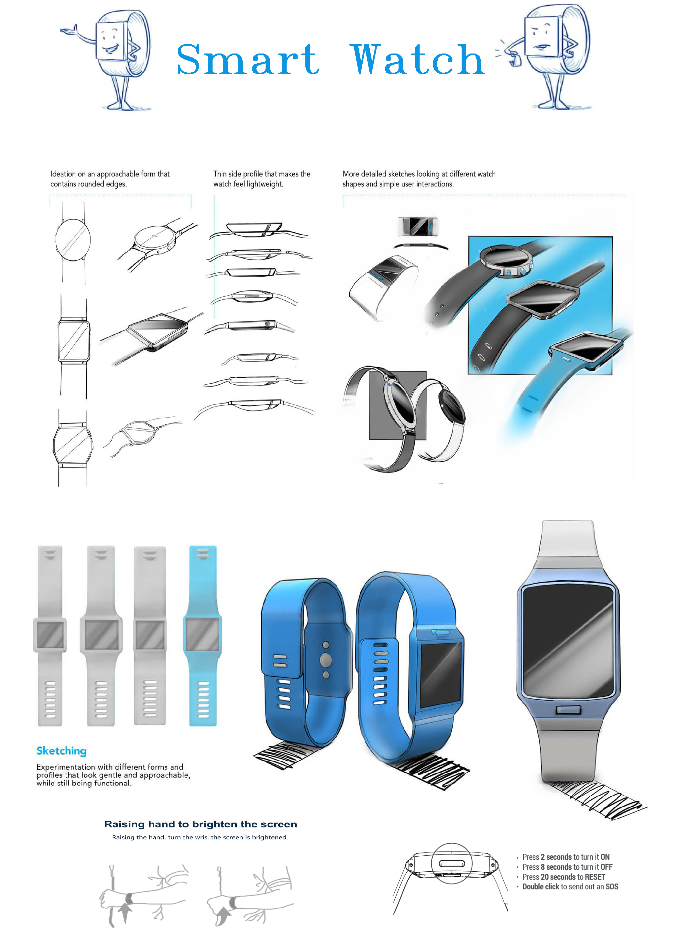

Figure 1 Smart Watch Concept

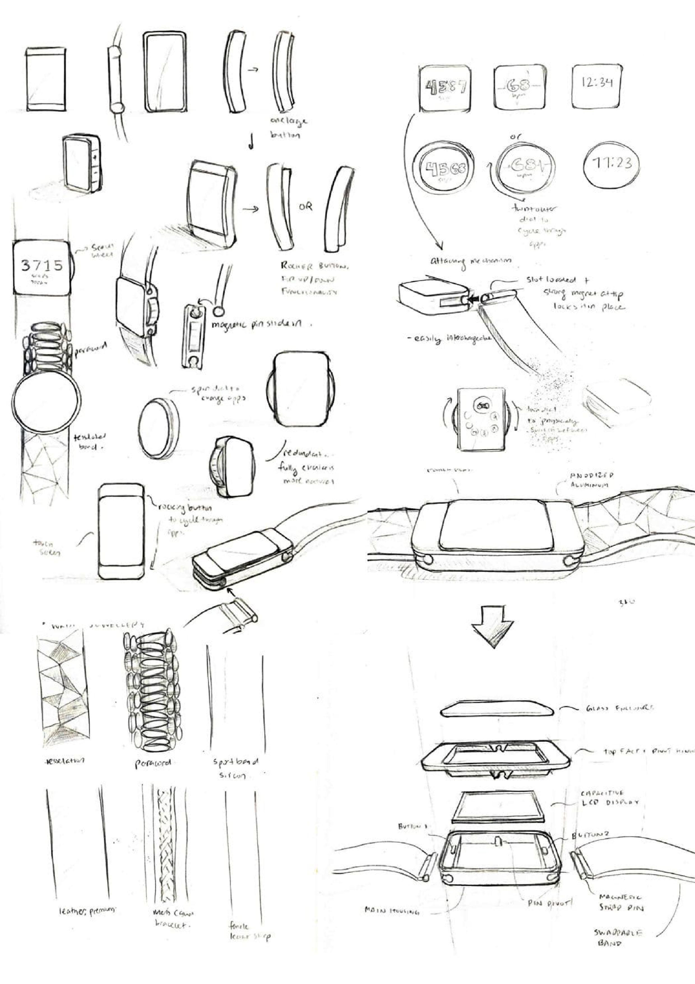

Figure 2 Smart Watch concept drawings

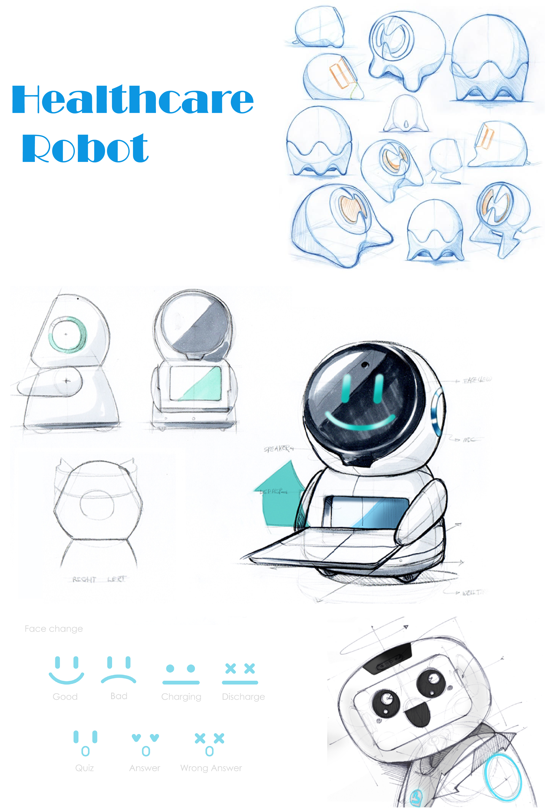

Figure 3 Healthcare robot concept